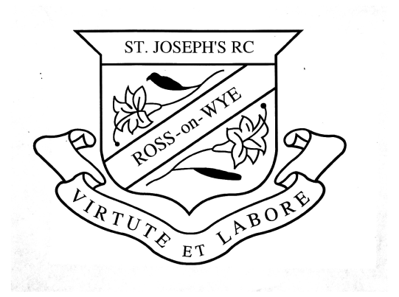
St Joseph’s Catholic Primary School
Ross on Wye, Herefordshire, HR9 5AW
Telephone: 01989 564655
Email: admin@st-josephs.hereford.sch.uk

Application for Admission for Catholic Children

Please complete and return this form to: St. Joseph’s Catholic Primary School at the above address, no later than 15th January 2027
Questions to be completed by Parent(s)/Guardian(s)

- Full Name of Child: ................................................................................. Date of Birth: ......................................

- Address…………………………………………………………………………………………………………………....
..................................................................................................................................................................................

................................................................................................................ Post Code: ..............................................

- Name of Parish: ..................................................................................................................................................

- Name of Parish Priest: .........................................................................................................................................

(Please ask the Parish Priest to complete the questions below. Please make the applicant’s Baptism Certificate available to the priest or provide evidence of reception into the Catholic Church.)

Name of parent(s)/guardian(s) (printed):.................................................................................................................

Signature(s): .................................................................................................. Date: ..............................................

Please feel free to add any further comments relevant to this application: .............................................................
..................................................................................................................................................................................
..................................................................................................................................................................................

Questions to be completed by Priest

- Name: ........................................................................ Parish: ............................................................................

- Can you confirm that the applicant is a baptised Roman Catholic or has been received into the Roman Catholic Church? Yes  No  (Please tick one)

Priest’s Signature: ........................................................................................ Date:...............................................

Please feel free to add any further comments relevant to this application: .............................................................
..................................................................................................................................................................................

Please make sure the applicants Baptism Certificate is available to the priest or provide evidence of reception into the Catholic Church. Failure to provide evidence of Catholic Baptism/Reception may affect the criterion the child’s name is placed in.
NOTE: Please note that you must complete a local authority application form.
This supplementary information form is only for school use to enable the governing body to rank applicants using the published criteria.

DEFINITION OF A “BAPTISED CATHOLIC”

A “Baptised Catholic” is one who:
- Has been baptised into full communion (Cf. Catechism of the Catholic Church, 837) with the Catholic Church by the Rites of Baptism of one of the various ritual Churches in communion with the See of Rome (i.e. Latin Rite, Byzantine Rite, Coptic, Syriac, etc, Cf. Catechism of the Catholic Church, 1203). Written evidence* of this baptism can be obtained by recourse to the Baptismal Registers of the church in which the baptism took place (Cf. Code of Canon Law, 877 & 878).
Or
- Has been validly baptised in a separated ecclesial community and subsequently received into full communion with the Catholic Church by the Right of Reception of Baptised Christians into the Full Communion of the Catholic Church. Written evidence of their baptism and reception into full communion with the Catholic Church can be obtained by recourse to the Register of Receptions, or in some cases, a sub-section of the Baptismal Registers of the church in which the Rite of Reception took place (Cf. Rite of Christian Initiation, 399).

